You have just started a new role as a Junior Software Developer at AQ Digital Solutions (AQDS), an independent software development company that designs and builds bespoke software solutions for various companies of different sizes that cover a range of different industries. The software that they design uses a wide range of technologies, from simple stand-alone programs to large web-based applications.
AQDS has been approached by a small, local company – North Sussex Judo – that specialises in providing judo training sessions to people from the local community. North Sussex Judo caters to people of all ages and experience, from expert to beginner.
North Sussex Judo has requested a simple program that will calculate the cost of training fees for their athletes each month.
The CEO of the company has reviewed the client requirements and has determined that this is a suitable project for you to take on. The company wants to see how you use and apply the ADQS development environments and code standards.
The requirements are that North Sussex Judo wants a program that will allow a user to enter the following information:
- athlete name
- training plan
- current weight in kilograms (kg)
- competition weight category
- number of competitions entered this month
- option to add the number of hours private coaching.

For each athlete, the program should then output the following information:
- the athlete’s name
- an itemised list of all costs for the month
- the total cost of training and competitions for the month
- how their current weight compares to their competition weight category.

North Sussex Judo currently have six athletes enrolled on their training program, but they would like the ability to register more.
You should use the additional information on the next page to help you when developing your program.
The client has not specified any Graphical User Interface, but the CEO has left the design of the program completely up to you.
Once the program has been built, the CEO has asked you to report back to them on how you designed and developed the algorithms required, as well as how you converted these algorithms into a final program and to show any issues you encountered.

As part of your report, the CEO wants you create a presentation for the development team showing the different programming paradigms available, as well as the debugging tools you used as part of the program development, so that the development team can review your progress.
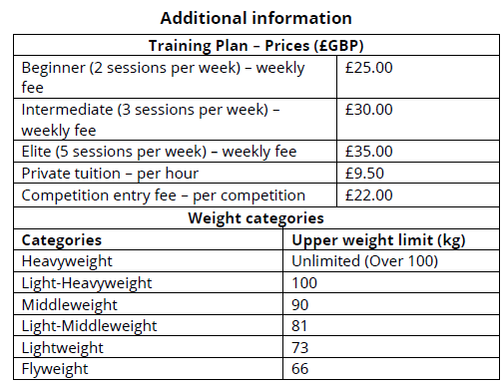

Athletes can receive a maximum of five hours’ private coaching a week
- Only Intermediate and Elite athletes can enter competitions
- Competitions are held on the second Saturday of each month
- All prices and costs should be displayed as currency to two decimal places
- The program deals with user error by displaying suitable messages to the user and then prompting them for another go
- North Sussex Judo assumes that a month consists of four weeks.

